FLABBY CAT
Joan and Mike Delaney, 2/6/05
(Parody of “Smelly Cat” by Phoebe Buffay on “Friends”)

Flabby cat, flabby cat
Why are you so very fat?
You just mope around the house
You don’t chase; you don’t mouse
You look like a fluffy mop
You never start; you only stop
Flabby cat, flabby cat
It’s not your fault

Flabby cat, flabby cat
I think you’ll have a heart attack
Your pressure’s up; your lipids high
You can’t jump; you only lie
You’re heading for the checkout zone
You’re gonna leave me all alone
Flabby cat, flabby cat
It’s not your fault

I’m gonna take you to the gym
I’ll work you out until you’re slim
The treadmill turns and turns so fast
So you won’t be—so ever-vast

Your tiny sneakers tied so tight
Won’t stop the pain until you’re light
You look cute pumping kitty weights
You lost a pound, I think that’s great

Skinny cat, skinny cat
Now you eat your low-carb rat
No kitty candy; not for you
Atkins would be proud of you
You’re so thin, you creep me out
Anorexic without a doubt
Skinny cat, skinny cat
It’s not your fault

A-part:
G C G D
G C D C G
Em Am Bm C
G C D C G

B-part:
D G
D G
A D
C D G

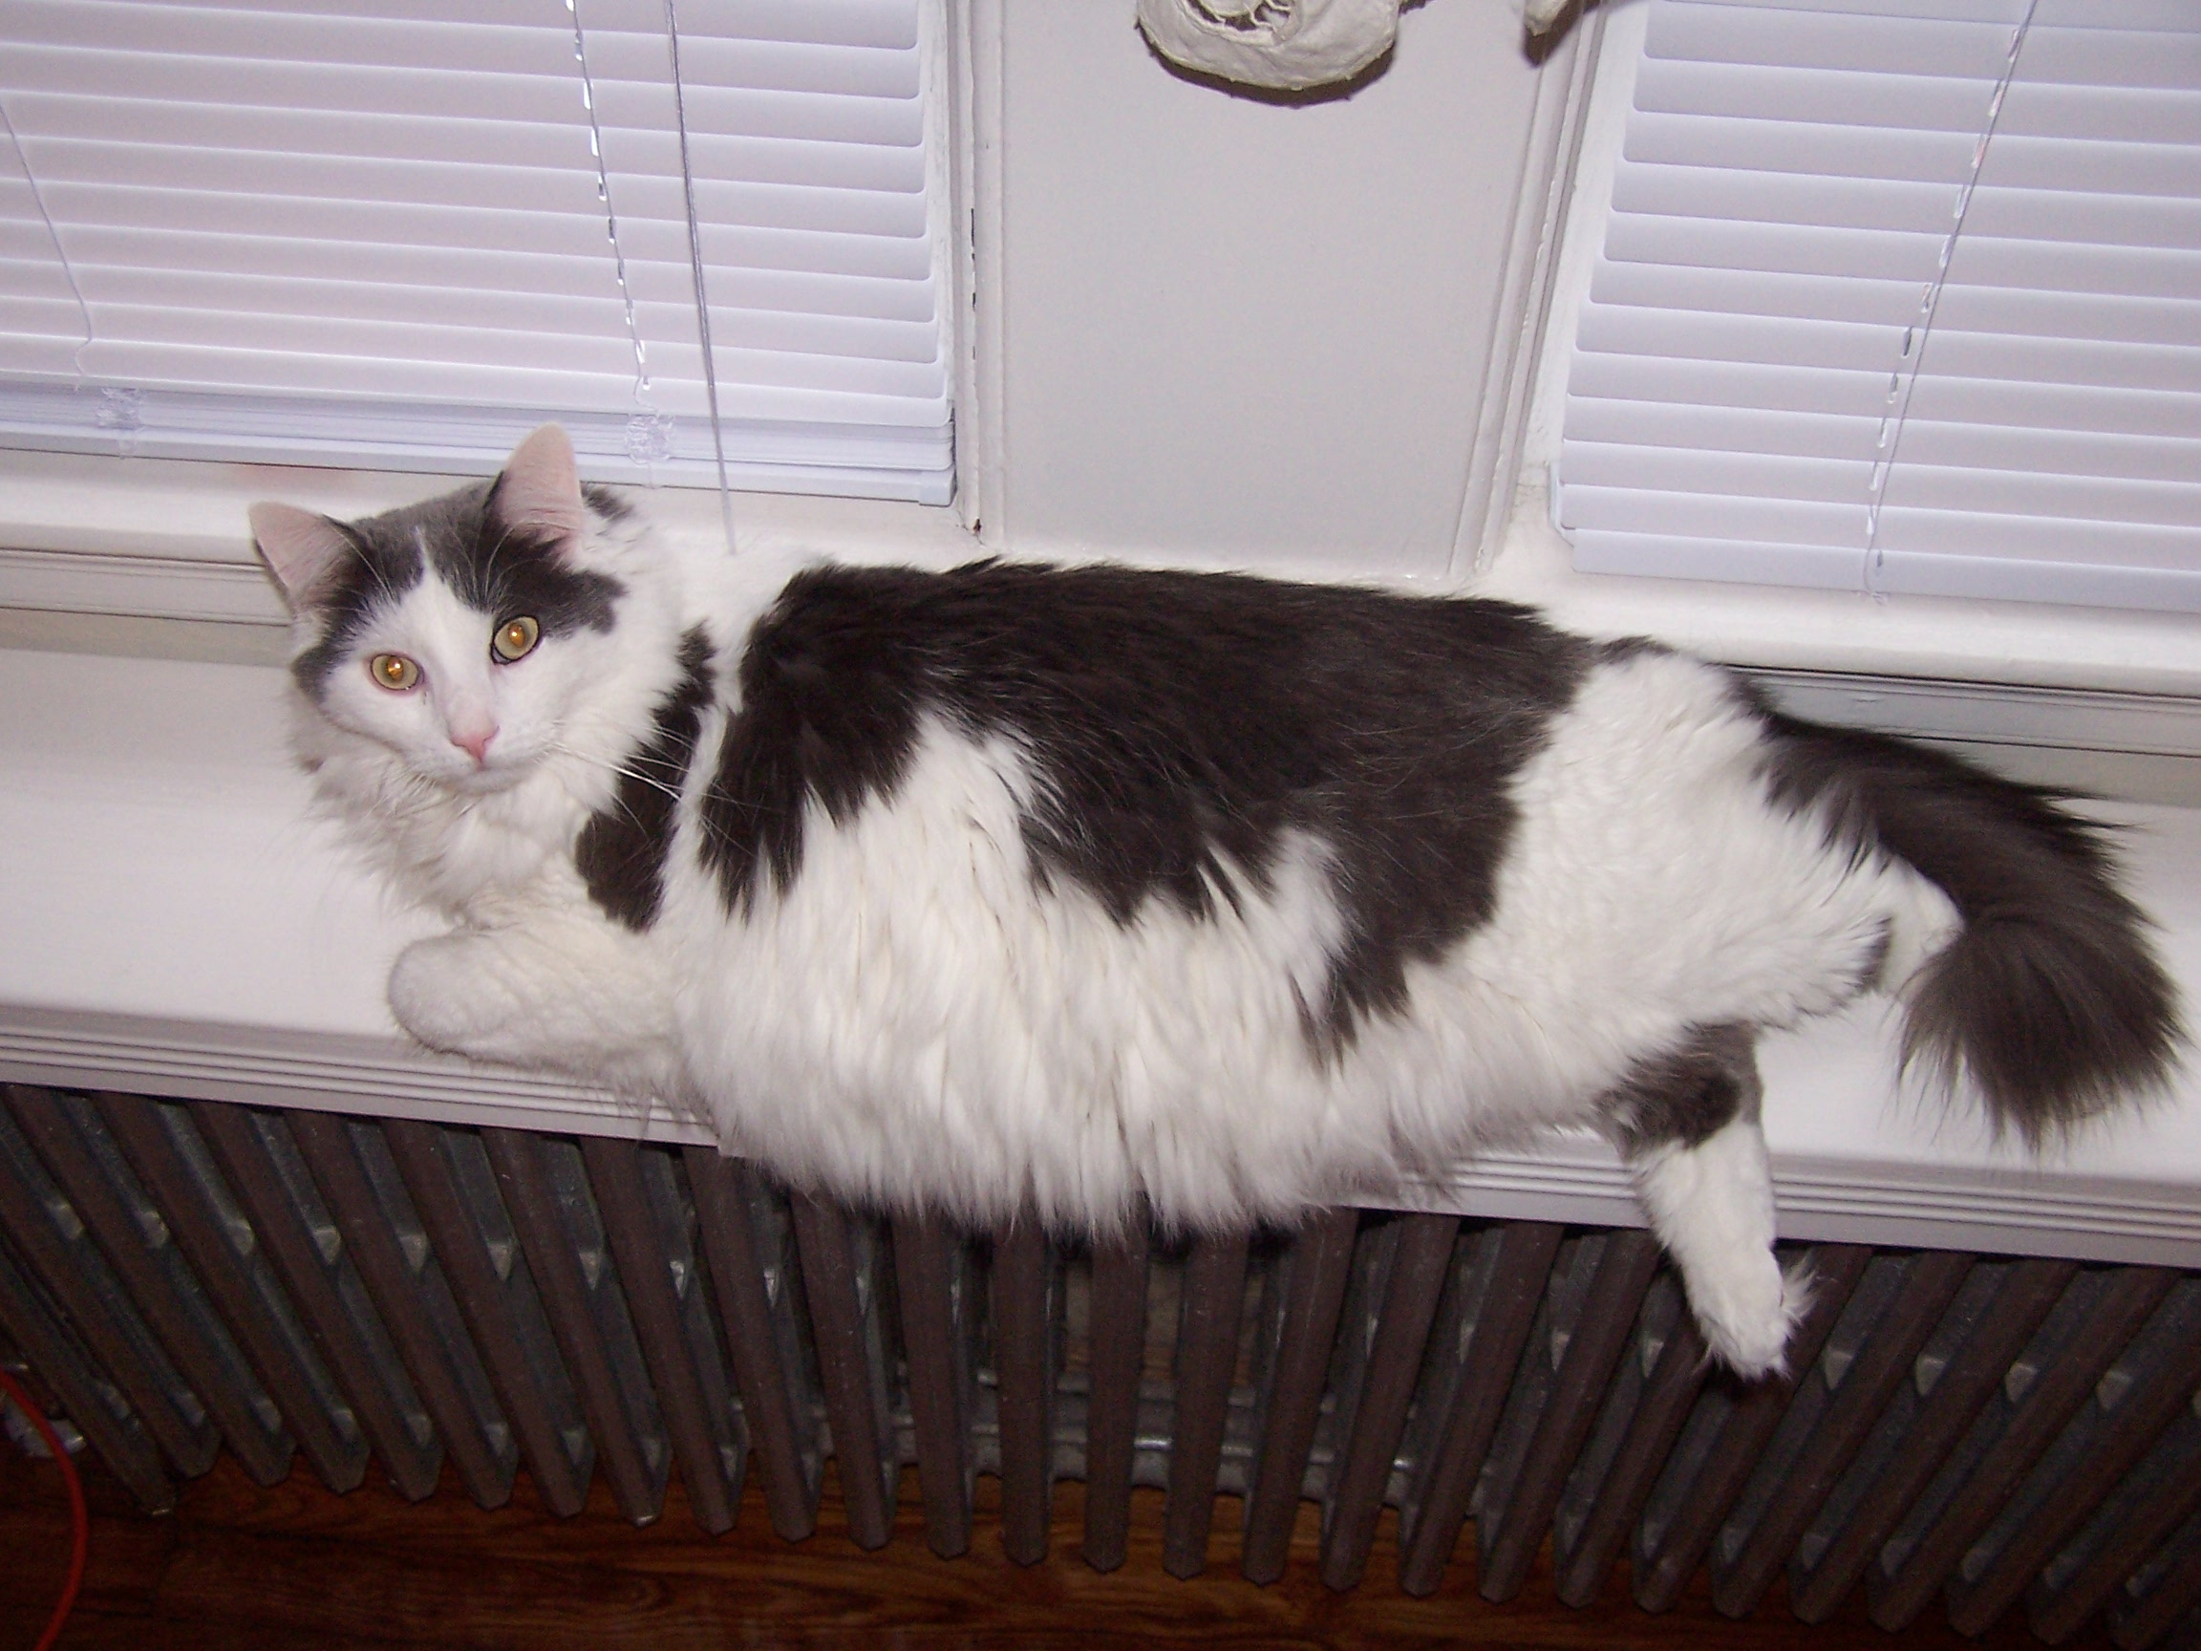
“Bud—a flabby cat”

